POC TASKS
Task 1: User & Permission Misconfigurations
Description:
Improper file permissions can allow unauthorized users to access sensitive system files, leading to privilege escalation. This task demonstrates how weak permissions pose security risks and how to secure them properly.
Setup: Creating Users & Misconfiguring Permissions
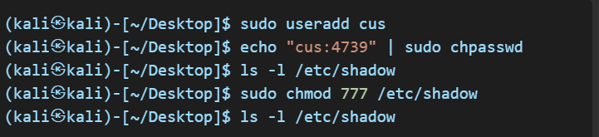

Exploitation: Accessing Sensitive Files

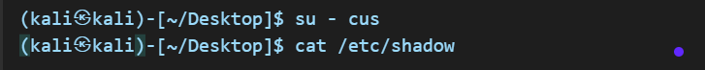Mitigation: Fixing Security Issues

Task 2: Remote Access & SSH Hardening
Description:
Weak SSH configurations can allow unauthorized users to gain system access. This task covers common SSH vulnerabilities and best practices for securing remote access.
Setup: Weak SSH Configuration
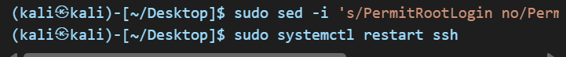
Mitigation: Secure SSH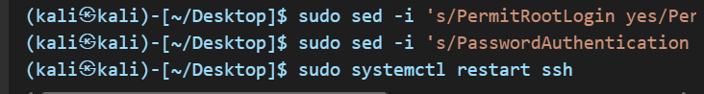
Task 3: Firewall & Network Security
Description:
A misconfigured firewall can expose a system to unauthorized access. This task demonstrates how to scan open ports and configure firewall rules for security.
Setup: Open Ports & Firewall Misconfigurations
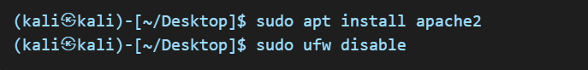
Mitigation: Restrict Access
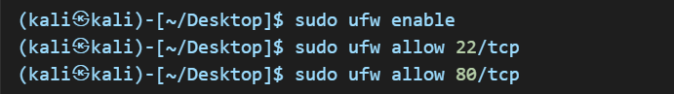

Task 4: SUID & Privilege Escalation
Description:
SUID binaries can be abused to gain unauthorized root access. This task highlights how attackers exploit SUID permissions and how to secure these files.

Setup: Exploitable SUID Permissions

Exploitation: Escalating Privileges
Mitigation: Remove Unnecessary SUID

Task 5: Automated Security Auditing & Scripting
Description:
Automated security monitoring helps detect vulnerabilities in real time. This task focuses on writing scripts to monitor login attempts and running services.
Setup: Writing a Security Audit Script
security_check.sh:
Mitigation: Automate Security Checks
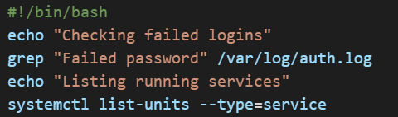

Task 6: Log Analysis & Intrusion Detection
Description:
System logs provide crucial insights into security threats. This task demonstrates how to analyze logs for failed authentication attempts and implement preventive measures.
Setup: Enabling System Logs
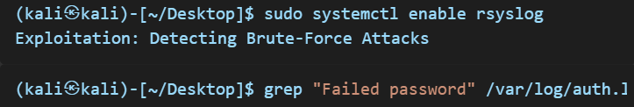

Mitigation: Use Fail2Ban

